

PSTAT 175

Survival Analysis

Dr. Andrew Carter

12/02/2018

“On Estimating and Modeling Burn Victims Time to Staphylococcus Infection**”**

By

Kevin Ayala

Table of Contents

Abstract 3

Data Overview 3

Differences in Hazard Function Between Groups 5

The Effect of Chlorhexidine Gluconate 8

Model Fitting, Choosing the Covariates 9

Model Diagnostics Checks 12

Interpretation of Coefficients 14

Extension, Recurrent Events 16

Conclusion 19

Bibliography, Works Cited 20

Appendix, R Code 21

# 

# Abstract

We apply the use of statistical techniques and methods of survival analysis to model the time till a staphylococcus aureus infection of burned subjects. Our data comes from a burn unit at a large Midwestern university. Some of the patients bathing was replaced by a total bathing routine using chlorhexidine gluconate for antimicrobial effect. The dataset contains 154 subjects with 18 different variables for each patient. The variable ‘Z11’ contains information about the type of burn the patients suffered from and is coded from 1-4, indicating a chemical, scald, electric, or flame type wound. Other variables account for the percentage of bodily injury, and indicators for where the injury occurred at. Other important variables include time to excision with status being if patient underwent excision or not, whether or not the patient received antibiotics, and if the patient suffered an infection. In total, we have three different times and statuses.

We apply the use of a Kaplan-Meier estimate to calculate probabilities of a patient suffering from an excision. We also compare survival rates for both women and men to find a difference between both groups as we expect their respective hazard functions to be different. We also apply this method to the type of burn type, and to the ethnicity of a patient. The use of ratio-test and log likelihoods are used to find significant differences in the data. Finally, we employ the use of a Cox Proportional Hazard model to model staphylococcus infection using various covariates and we conducted diagnostic checks on our model in order to deem it valid

# Data Overview

The dataset contains information regarding patient bathing. The main concern is to see if a total bathing routine involving chlorhexidine gluconate would be an effective counter measure towards reducing the probability of having a staphylococcus Infection. Out of the 154 burn patients, roughly half of them received the chlorhexidine gluconate (54% of patients) bathing routing and the other 46% of patients used the hospitals routine bathing with no chlorhexidine gluconate. Our data came from the “KMSurv” library on the open source program R-studio. A brief synopsis of the data can be read in “Evaluation of Protocol Change in Burn-Care Management Using the Cox Proportional Hazards Model with Time-Dependent Covariates.” by Ichida, J M, et al. More information in bibliography.

The following table is a summary of the variables in our dataset, and what they represent. They will be referred to frequently during the analysis, and we will further explain the meaning of the variables as well to give further insight.

Variable Names Variable Meaning

|  |  |
| --- | --- |
| Z1 | Treatment: 0-routine bathing 1-Body cleansing |
| Z2 | Gender (0=male 1=female) |
| Z3 | Race: 0=nonwhite 1=white |
| Z4 | Percentage of total surface area burned |
| Z5 | Burn site indicator: head 1=yes, 0=no |
| Z6 | Burn site indicator: buttock 1=yes, 0=no |
| Z7 | Burn site indicator: trunk 1=yes, 0=no |
| Z8 | Burn site indicator: upper leg 1=yes, 0=no |
| Z9 | Burn site indicator: lower leg 1=yes, 0=no |
| Z10 | Burn site indicator: respiratory tract 1=yes, 0=no |
| Z11 | Type of burn: 1=chemical, 2=scald, 3=electric, 4=flame |
| T1 | Time to excision or on study time |
| D1 | Excision indicator: 1=yes 0=no |
| T2 | Time to prophylactic antibiotic treatment or on study time |
| D2 | Prophylactic antibiotic treatment: 1=yes 0=no |
| T3 | Time to straphylocous aureaus infection or on study time |
| D3 | Straphylocous aureaus infection: 1=yes 0=no |

An overview of the data reveals that out of the 154 burn patients, the average bodily burn percentage for all patients was 24.69%, with the most frequent burn area being the trunk area with 130 occurrences. A bar plot reveals to us the frequency of each burn location. From the patients, we clearly see in the plot in figure 1.1 that a burn in the upper leg and in the head are similar in count with buttock having the least occurrences.

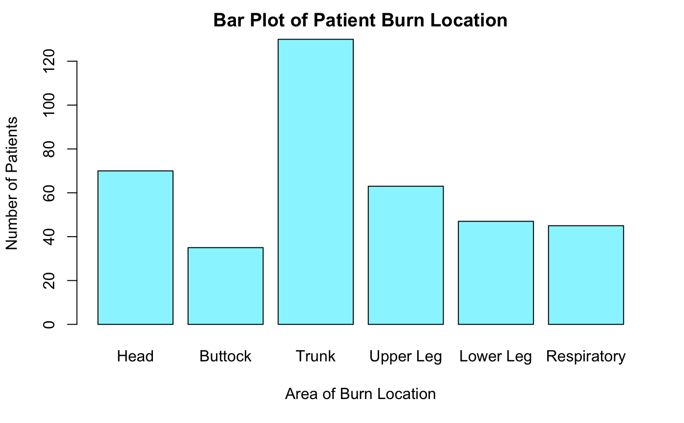

There was also a similar number of respiratory tract burns along with lower leg burn injuries. The percentages of the burns amongst the subjects are as follows; 84% for the trunk, 41% for the upper leg, 45% on the head, 31% on the lower leg, and 29% in

the respiratory tract. We note that the bar graph does not take into consideration the type of burn, only the total number of burns for each area.

Further analysis of the data reveals that out of the 154 patients, 34 were female and rest were male, a total of 130 males. This is a large difference in the data between subjects being men (84.4%) and women (15.6%). This may be indicative of the stereotype that men are often working under harsher conditions in high risk industries such as in construction, landscaping, and factories where flame type accidents can occur. Men are also more likely to be in fields dealing with hands on interactions with electricity. Another key aspect of the data has to do in regard to ethnicity. The data contains 135 patients who are classified as white and the remaining 19 patients have their ethnicity classified as “non-white”.

A Kaplan-Meier plot between the four different burn types with respect to time till excision in figure 1.2 gives us insight on the nature of the type of burns. Excision is a surgical procedure used by doctors to remove traumatized area due to the burn being severe. We will not go into the details of the procedure but if interested, more about excision can be read on the article “Early Burn Wound Excision Significantly Reduces Blood Loss” by Desai, in *Annals of Surgery.* (Desai, Manu H).

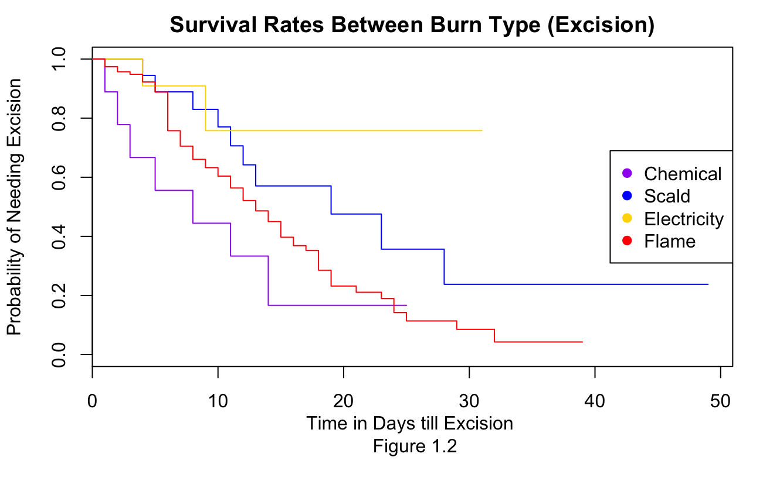

The Kaplan-Meier plot in figure 1.2 was used as an exploratory data analysis method for a quick overview and understanding of the nature of burn types. From figure 1.2 we see that there may be a significant need for patients to undergo excision if the burn type happens to be a burn caused by electricity. We can see from the plot that the probability of needing excision stays relatively high and seems to hover around 75% after around 8 days. This is in line with what we expected as electric burns are the most unique, hence we found it reasonable to assume they would be the most dangerous. The KM plot of chemical burns also reveals that it may be the least dangerous if we consider how quickly the probability of needing excision falls with respect to the other type of burns. A key point of this Kaplan-Meier estimate is that a scald and flame type burn seem to be potentially similar, and a confidence interval will reveal if the survival hazard is the same or not. These kinds of interactions between burns will later be considered in the next section. An important note with the Kaplan-Meier plot is that it is a non-parametric technique, thus it only takes into account the time of excision and the status if the subject underwent the procedure or not without regard to other variables.

# Differences in Hazard Function Between Groups

We were interested to see if there was a significant difference between groups such male and female, white and nonwhite, as well as to see if the burn type plays an important role. First let us consider the male-female comparison. We use a Kaplan-Meier estimate of both populations to see if there is a significant difference between both groups. We calculated these ratios by using Greenwoods formula for variance, since by the method of Kaplan-Meier as a non-parametric method, we can compute a 95% percent confidence interval by the following,

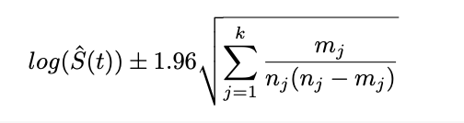

Where S hat (t) denotes the hazard function with respect to a given time and take its log for convenience For simplicity, more on greenwoods formula can be read in “Corrections: Modification of the Greenwood Formula for Correlated Response Times.”

(Biometrics). We then obtained our confidence interval by multiplying the corresponding z-value for the level of confidence that we want, in this case 1.96 which yields a 95% confidence interval. Then multiply it by greenwoods formula to get a standard error for our non-parametric method. Inside the square root we have greenwoods formula where mj denotes the number of failures for the risk set and nj denotes the number of patients exposed, or the number of patients at risk to fall into a failure at a given time period.

For gender differences in regard to excision time, figure 2.1 outlines a survival probability for the two groups, at a first glance we notice that at a 95% confidence interval, there seems to exist a possible hazard rate where the true survival rate for both groups may be the same. A snippet of the 95% confidence intervals at any time t can be seen in figure 2.1. For a complete numerical confidence intervals for any time t under either gender, can be found in the appendix under the code,

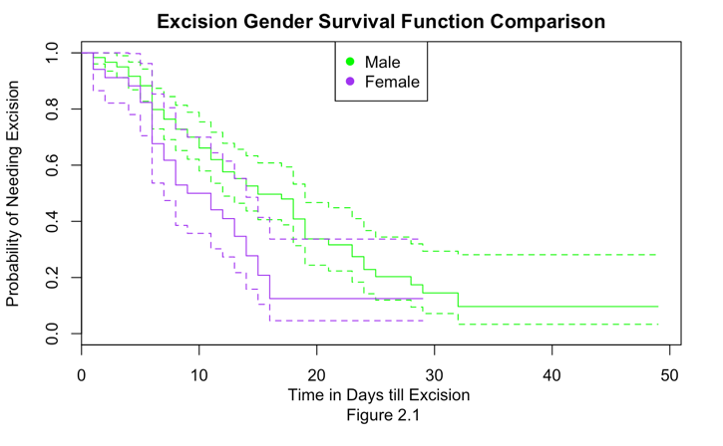

excision.gender <- survfit(Surv(burn$T1, burn$D1)~Z2, data=burn)

summary(excision.gender)

The following is a short snapshot of the hazard ratio, Z2 is the gender indicator variable and 1 denotes female.

Z2=1

time n.risk n.event survival std.err lower 95% CI upper 95% CI

1 34 2 0.941 0.0404 0.8653 1.000

2 32 1 0.912 0.0486 0.8212 1.000

4 31 1 0.882 0.0553 0.7804 0.998

How to read the table? Under the summary, nj is denoted by n.risk, and mj

is denoted by n.event, std.err represents the square root of Greenwoods formula. Using the example above, we find that the true hazard rate for the female group at time 4 lies with the interval (.7804, .998) at a 95% level of significance. Again, the full length of the code can be found in the appendix.

To test the validity of gender groups being different, we fitted a cox proportional hazard regression model below with only the gender indicator variable, since this is the only variable taken into account, this is equivalent to a likelihood ratio test to see if there is any significant difference.

Call:

coxph(formula = Surv(T1, D1) ~ Z2, data = burn)

coef exp(coef) se(coef) z p

Z2 0.623 1.864 0.227 2.75 0.006

Likelihood ratio test=6.89 on 1 df, p=0.009

n= 154, number of events= 99

It is revealed that with a p-value of .009, that there is significant difference between the two groups. This is also likely when all other variables in the model are considered. Our corresponding null hypothesis is H0: S1(t) = S2(t) for the group of men and women. Thus we conclude that the survival rates for both groups of Sex to be different at a 95% level of confidence.

Now moving on to ethnicity, we were curious to see if the ethnicity factor had any significant effect on the survival rates for whites v. non-whites. A likelihood test given by the below,

Call:

survdiff(formula = Surv(T1, D1) ~ Z3, data = burn)

N Observed Expected (O-E)^2/E (O-E)^2/V

Z3=0 19 13 13.2 0.002792 0.00346

Z3=1 135 86 85.8 0.000429 0.00346

Chisq= 0 on 1 degrees of freedom, p= 1

reveals a high p-value of 1, there is no significant difference between the two groups; whites and nonwhites. Our null hypothesis is H0 : S1(t) = S2(t) for the group of whites and non-whites, we thus concluded that the survival rates for both ethnicity group to be the same at a 95% level of confidence by rejecting the null. From the figure on the left which outlines the survival probability for both ethnicity groups reveals similar hazard rates for both groups on a visual basis. This is in consideration to the fact that people labeled “white” outnumbered non-whites by

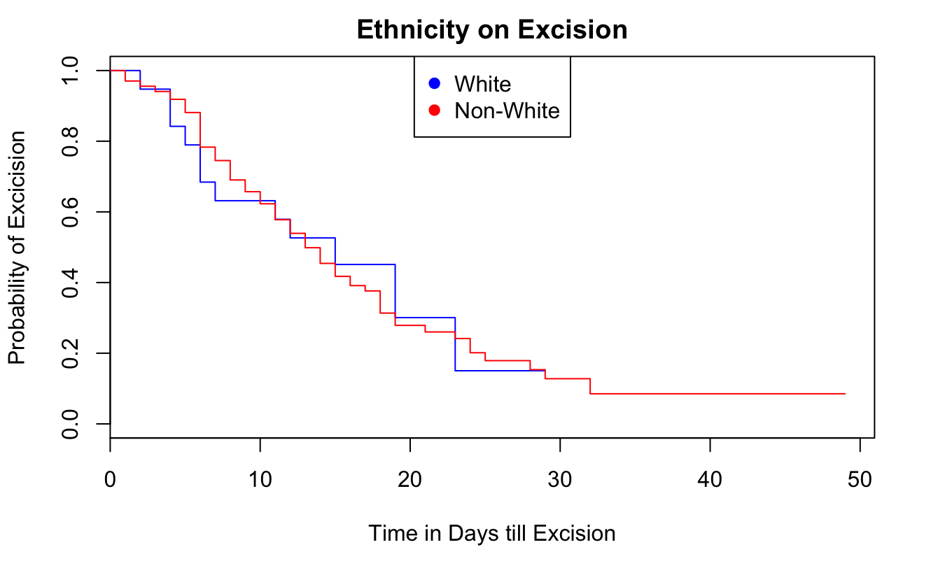

over 70%. We concluded the true hazard rate between the two ethnic groups are the same.

Lastly, and probably the most important, we wanted to observe if the survival rate was different for the different types of burns, such as chemical, scald, electric, or flame. A log likelihood test given by the below:

Call:

survdiff(formula = Surv(T1, D1) ~ Z11, data = burn)

N Observed Expected (O-E)^2/E (O-E)^2/V

Z11=1 9 7 4.23 1.818 2.02

Z11=2 18 10 15.71 2.077 2.67

Z11=3 11 2 6.33 2.961 3.36

Z11=4 116 80 72.73 0.727 2.95

Chisq= 8.1 on 3 degrees of freedom, p= 0.04

From this likelihood test, we can see that z11=4 (burn) has the greatest number of victims. Our null hypothesis is H0 : S1(t) = S2(t) =S3(t)=S4(t) for the different burn types. Since the p-value is 0.04 less than our alpha value of 0.05, we concluded that survival rates for all the different types of burn are not the same at a 95% significant level. Therefore, we reject the null hypothesis. The type of burn does have an effect on the patient’s true survival rate. With these results, we expect that gender along with burn type would play a vital role in modeling time to staphylococcus.

# The Effect of Chlorhexidine Gluconate

Our treatment group within the data is subjects who underwent a total body bath of chlorhexidine gluconate. These subjects are coded as 1 under the Z1 dummy variable. Using a cox proportional hazard model on the cleansing routine of a subject, we observed a likelihood ratio test of 7.04 on 1 degree of freedom with a corresponding p-value of .008. We thus rejected the null hypothesis S1(t) = S2(t) between both routines, we found evidence that the hazard function between treatment group (chlorhexidine gluconate), and routine bathing is different such that S1(t) ≠ S2(t). We used a log likelihood under a cox ph regression. We used the time to antibiotic (T2) and antibiotic status (D2) as we felt that the type of bathing a subject underwent would have an effect on whether or not their need for an antibiotic would change.

coxph(formula = Surv(T2, D2) ~ Z1, data = burn)

coef exp(coef) se(coef) z p

Z1 0.691 1.996 0.268 2.58 0.01

Likelihood ratio test=7.04 on 1 df, p=0.008

n= 154, number of events= 63

We observed a hazard coefficient of 1.996, meaning that the risk of needing to take prophylactic antibiotic decreases since the hazard coefficient is greater than 1. Prophylactic antibiotics are antibiotics that are used so that a potential staphylococcus aureus infection may be avoided. Since the hazard function decreases for the treatment group, we find that it indicates that the patient has lowered the risk of contracting a staphylococcus infection on the wounded area. We observed a 95 percent confidence interval of the true hazard ratio between the interval of (1.18, 3.378).

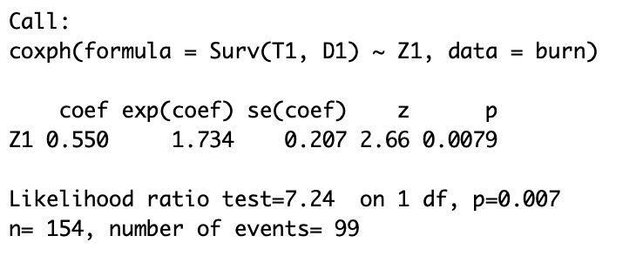We also checked if there was a difference under excision time and status, and overall the results seem to be similar to our previous conclusion with very slight variation. We still reject the null and conclude there is a difference between the control group and the treatment group.

We can also see the difference visually between the control group and the treatment group in figure 3.1. As confirmation to our earlier conclusion regarding the effect of treatment, we clearly see that the treatment group has a lower hazard function at time t.

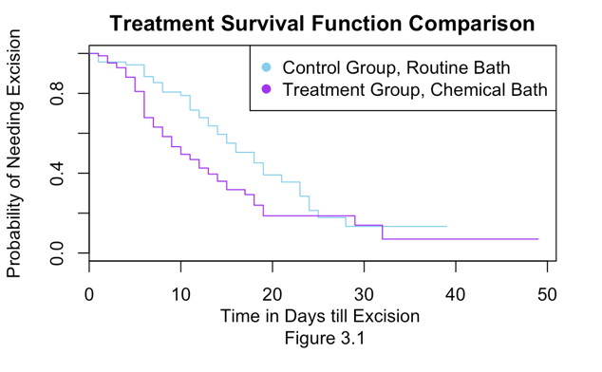

# Model Fitting, Choosing the Covariates

We began the process of choosing our parameters for prediction of excision time by fitting a model with all covariates, a full model. We believe that excision time to be important and may perhaps have an effect on whether or not a patient will become infected with staphylococcus as less wounded area will decrease the risk for infection due to less bacteria. We will later on make another model in regard to the staphylococcus infection. Earlier, since we concluded that the treatment bathing was effective at reducing the probability of needing excision, we expect to see this treatment trend variable to be important for both models. We also expect gender to play a significant role based on the previous section where we found hazard ratios for both groups to be different. We chose the model to be a Cox-Proportional Hazards Regression since it has the advantage of being a semi-parametric model. For choosing the right set of covariates to model time to excision, an Akaike Information Criterion approach was used for choosing the most significant covariates.

AIC is a criterion in which assumes a model with covariates of size M, are compared to one another by taking the maximum likely estimate in the form below.



Under this criterion, we then chose our model based upon a backward direction step function. It is important to note that choice in direction leads to a different model, this is known as the stepwise paradox where forward direction and backward model selection may not converge to the same model.

Under this process, we encountered that that best model for predicting excision time and status, was a model with the following covariates,

Z1 , Z2 , Z4 , Z8 , Z9 , T3

with a corresponding AIC value of 815.46. This was the lowest AIC criterion score for all models. We found it appropriate to use a step function considering the dataset has 16 variables not including the observation column. We again find that Z1 was significant, the bathing routine indicator. We again note the previous section that we found the chemical bathing routine to be effective in reducing the risk of needing antibiotics. This further indicated a possible latent variable in which decreased risk of needing antibiotics was also correlated with decreased risk of staphylococcus infection.

We were also not surprised that Z2 (Burn Type) was also included in this model. Recall from the data overview section that we found that the hazard function for each group under burn type to be different. Thus, we are glad that the model takes burn type into consideration.

We were also not surprised about the inclusion of the Z4 (total percentage of body burned) variable. We suspected this variable would be important as we believe that patients who have larger burned body percentage suffered from a more severe burn accident and thus it makes sense that a more severe burn would lead to excision.

We did not expect the inclusion of the Z8 (upper leg burn site indicator) and Z9 (lower leg burn site indicator) variable. We expected the trunk burn site indicator (Z7) to be in this model as it was the most frequent burn site amongst all subjects. Lower leg burn accounted for 31% of subjects and upper leg burn accounted for 41% of burn patients. One possible explanation may be that the legs are often the least protected area of the human body in rough industries. Since our legs is mostly flesh, it makes sense that it may be easier to perform excision on. Under further analysis, we decided to run this model under another stepwise operation where we could find potential interactions, between the model. We found an interaction between the treatment indicator variable Z1 and the bodily injury burn percentage Z4. This made sense as we expected the bathing treatment to have a more widespread effect when bodily burn percentage was high. The last interaction was between whether or not the subject was male or female, and whether or not the subject suffered from a wound in the leg.

Once we had our important covariates, we once again ran through a stepwise regression function in order to find potential interaction terms, which yielded the following variables as important,

Z1, Z2 , Z4 , Z8 , Z9 , T3 , Z1:Z4 , Z2:Z8

This model with interactions has a corresponding AIC value of 814.89 and we find it a better fit than the previous model since it has the inclusion of interaction terms.

We believe that it is important to model time to excision based on our predictors because when we try to model time to staphylococcus infection, we find that the indicator for weather a subject underwent excision or not plays a role in the model for staphylococcus. Under similar AIC conditions and a stepwise function in the backward direction, we find that the best model for prediction a staphylococcus infection is given by the model

Coxph(Surv(T3, D3) ~ Z1 + Z2 + Z3 + Z6 + D1 + D2)

We again encounter the variables of treatment indicator (Z11) and gender indicator Z2. This was again expected. We were alarmed with the presence of the Z3 variable, which indicated whether a subject was white or non-white. In the earlier section, we found evidence that the hazard function between both groups were the same. However, we came to that conclusion that using the nonparametric approach. We now conclude that the variable is significant under a cox proportional hazard model. Buttock was also significant for this model, there is no additional information in the dataset that might help explain why this is a significant predictor.

We believe this is due to the buttock being a “sensitive” area of the human body. In fact, according to Merchant and Willoughby, “Perineal and buttock burns are challenging wounds to heal for several reasons because of the contamination risk and shear stress that is always present. Because of the nature of the wound bed, pathogens can have ready access to create systemic infections and complications.” We believe this is why we have the buttock indicator in our model.

What we found the most interesting however, was the incorporation of the D1 and D2 status variable. This means that it matters if a patient underwent excision and if they were also put on antibiotics. Since both of these indicators were put considered significant in the model selection process, then this indicates that excision can possibly act as a preventative measure along with antibiotics. It is quite obvious that antibiotics would decrease the risk of infection, so we were not surprised regarding this outcome.

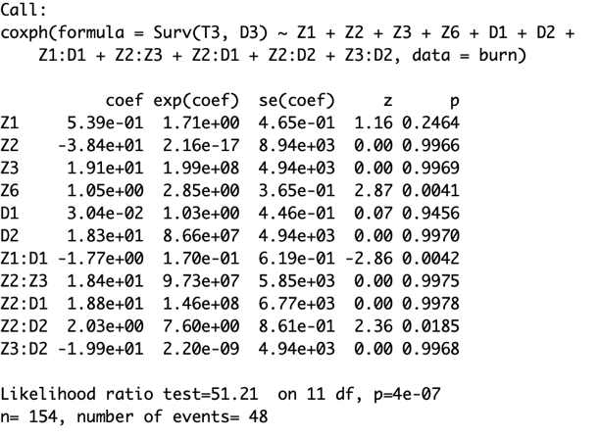 We once again underwent a similar stepwise process for possible interaction terms, we again find this more appropriate than the previous model. Thus, our final model has an AIC score of 409.37. We found the “coef” column to be important and are the coefficients that we used in our final cox regression model for staphylococcus. Thus, we decided that our model for predicting a staphylococcus infection has the form of

hi(t) = h0(t)·exp[.538x1i -38.37x2i + 19.1x3i + 1.04x4i + .0304x5i + 18.27x6i -1.7732x1ix5i + 18.39x2ix3i + 18.39x2ix3i + 18.79x2ix5i + 2.02x2ix6i – 19.93565x3ix6i

Where h0(t) represents the baseline at a given time point t.

# Model Diagnostics Checks

Once we had chosen our final model for predicting a staphylococcus infection, we conducted diagnostic checks so that the model is appropriate in order to avoid distorted predictions. We were particularly interested that the model does indeed satisfy the cox proportion hazard assumption. We checked this assumption by conducting the coxzph function on the model, the coxzph function works by performing a test to see if the model is significantly divergent from proportional hazards model. The corresponding null hypothesis is that the proportional hazard assumption is not violated, in contrast the alternative is that the ph assumption has indeed been violated.

Upon using the coxzph function on the staphylococcus infection model with interactions, we are left with the following result on the lowerleft.

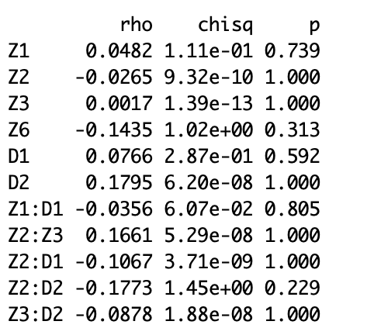 cox.zph(befit2, global = FALSE)

We notice that none of the p-values are significant and thus we fail to reject the null that this model satisfies the proportional hazard model. We also checked this assumption by employing the use of negative log log plots below. As we can see, we notice that all graphs have no crossing and seem almost perfectly parallel to one another, indicating that the proportional hazard assumption is indeed met and thus cross validates the use of the coxzph function. One thing to note is the log log plot of Buttock are so close to each that it looks like they could be on the same line, however we interpret this as still being parallel as there is no obvious indication that there is crossing.

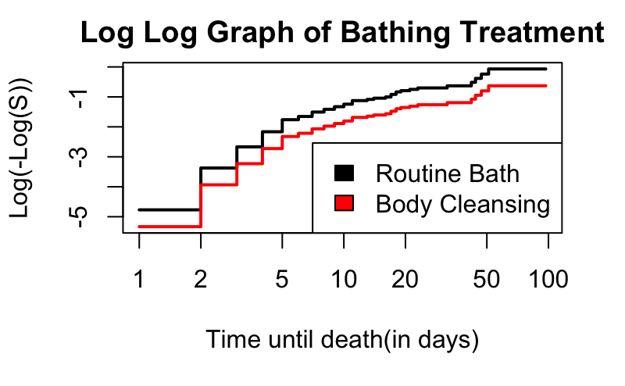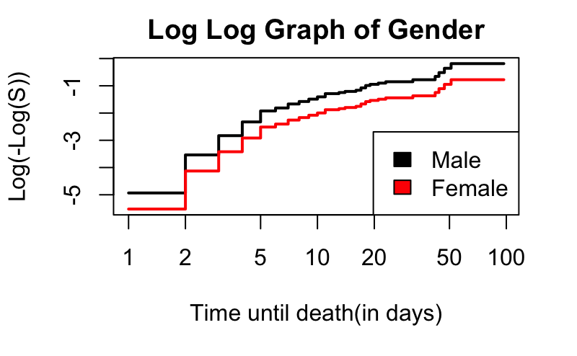

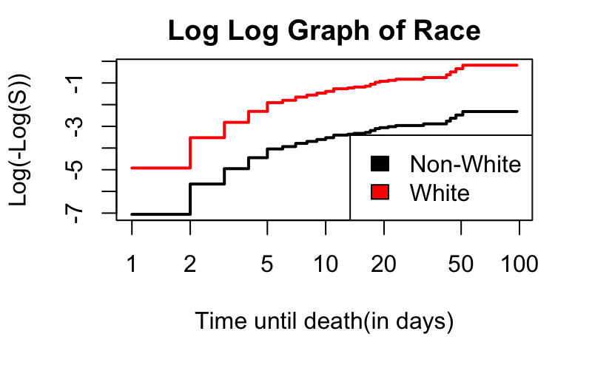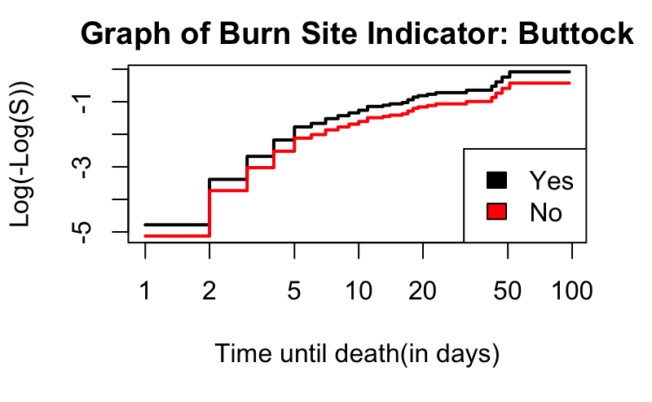

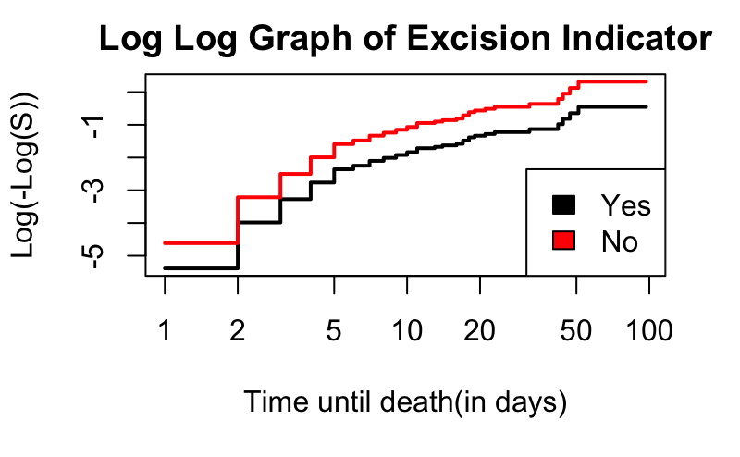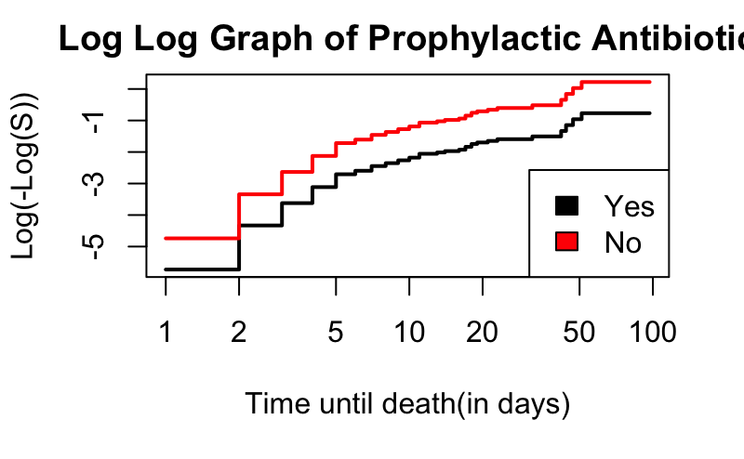

After we found the proportional hazard assumption appropriate, we then concluded that the cox regression model was appropriate, and would predict with no distorted estimates.

# Interpretation of Coefficients

Now that we have our final model pass through diagnostic checks, it was important to interpret the meaning of our coefficients. As a reminder when it comes to coefficient interpretation, we have that

If β = 0 then the hazard function is the same for everyone.

If β > 0 then increases in x cause increased hazards and shorter survival times.

If β < 0 then increases in x cause decreased hazard and longer survival times

In consideration to this we have that our z1 variable, the dummy variable for indication of treatment vs control group was greater than 0 and thus we interpret that body cleansing increases the hazard function and thus results in a shorter survival time. This is in contrast to our earlier finding where we found that chemical bathing decreased the risk for excision. We would expect that a decrease in needing excision would imply a not so sever burn and thus result in a lower staphylococcus infection. However, the reason this finding contradicts that certain finding from earlier was the fact that the KM method was used to estimate a hazard function and thus was non-parametric. Since the cox model is a semi-parametric test, it takes into account the other covariates in the model and is perhaps the reason this result turned out so differently. We were correct in assuming that the treatment indicator would indeed play a part in a final model.

The Z3 coefficient is greater than zero and is the ethnic indicator. “Nonwhite” are coded as 0, thus we interpret this coefficient having an increase hazard rate compared to those who were labeled white and thus shorter survival time.

Z6 coefficient is an interesting case, it was greater than zero, meaning that having burn site on the buttocks means an increase in hazard rate and shorter survival time for a staphylococcus infection.

Our D1 coefficient is greater than zero. We must remember that D1 was the status if a patient underwent excision. This means that having an excision increases hazard rate and results in a shorter survival time. This is an anomaly and we may ignore it since excision in our model plays an interactive effect. We keep all interaction terms in the model due to the frequentist tradition of always keeping them. Thus, perhaps it is balanced out by the interaction, leading to a decrease in the hazard function.

The D2 (antibiotic treatment) indicator coefficient β is greater than zero, meaning that having an antibiotic treatment increases hazard rate and shorter survival. However, when it’s placed as an interaction term it decreases in hazard rate and has a longer survival time.

We also have 95% confidence intervals for the coefficients and they are as follows

|  |
| --- |
| > Z1 Variable (Treatment)        2.5 % 97.5 %  **0.4448873 1.43752** |
| > Z2 Variable (Gender)        2.5 % 97.5 %  **0.4781636 2.230845** |
| > Z3 Variable, (White)       2.5 %   97.5 %  **1.012169 53.46058** |
| > Z6 Variable, (Burn Site Indicater, Buttock)        2.5 % 97.5 %  **0.5603711 2.025716** |
| > D1 Variable, (Excision)        2.5 % 97.5 %  **0.7908049 2.596167** |
| > D2 Variable, (Prophylactic antibiotic)       2.5 %   97.5 %  **0.397181 1.397918** |

# 

# Extension, Recurrent Events

Due to our burn data set having multiple events that can occur before a staphylococcus infection, we decided to see if a recurrent model would be more appropriate. We wanted to see if events happening prior to our D3 (staphylococcus variable indicator) had any effect on the survival rate of getting an infection. In recurrent events modeling, there are multiple events for each person where each person has multiple different times. We split our data into time episodes, we chose to make this time split at 20 days, from 20 to 40 days and after 40 days on study or until a staphylococcus infection

In figure 4.1, we plotted the Recurrent Survival Function when we do not include other covariates in the data. If we pay attention closely to this graph, we notice that since we did not include other covariates, then this coxph model plot is equivalent to a Kaplan-Meier survival estimate. We did this so that we may later compare plots where we compared the group of taking an antibiotic as well as the group of subjects who did not use antibiotics.

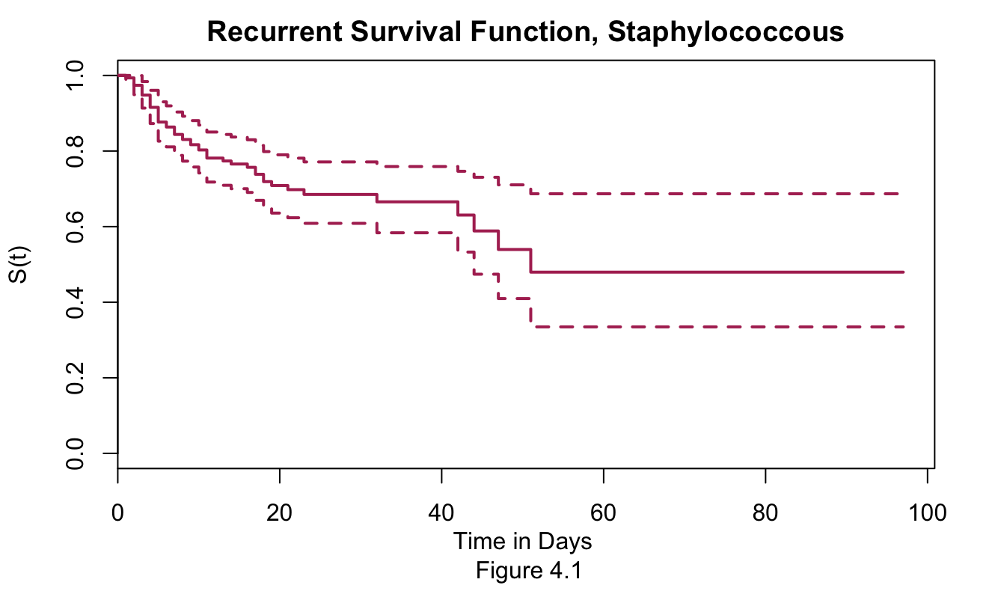

When we look into treatment and non-treatment groups, we notice that the treatment bathing is having a great effect on its own by greatly reducing the risk of getting an infection. Further analysis on the time episodes may give us greater insights and we may be able draw conclusions about how the risk of infection is changing with respect to time and possible other variables as well.

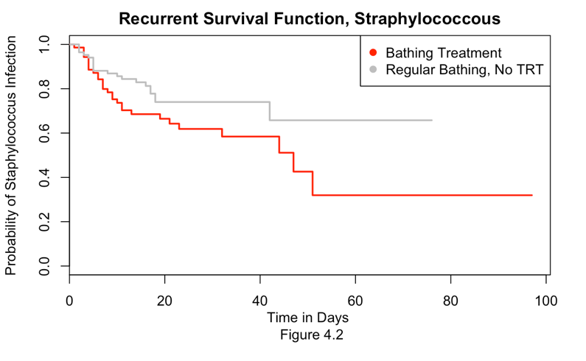

Looking at plot 4.3, we notice that the group on antibiotics has a noticeable lower probability of getting a staphylococcus infection. This makes complete sense as we completely expect that an antibiotic would lower the chances of getting an infection, this belief stems from what we have observed, where we live in a country where it is customary to receive vaccinations and preventative treatments. Hence why healthcare is a big topic in the political climate. There is a noticeable difference in the groups so we concluded that the antibiotic was successful in lowering the risk of infection.

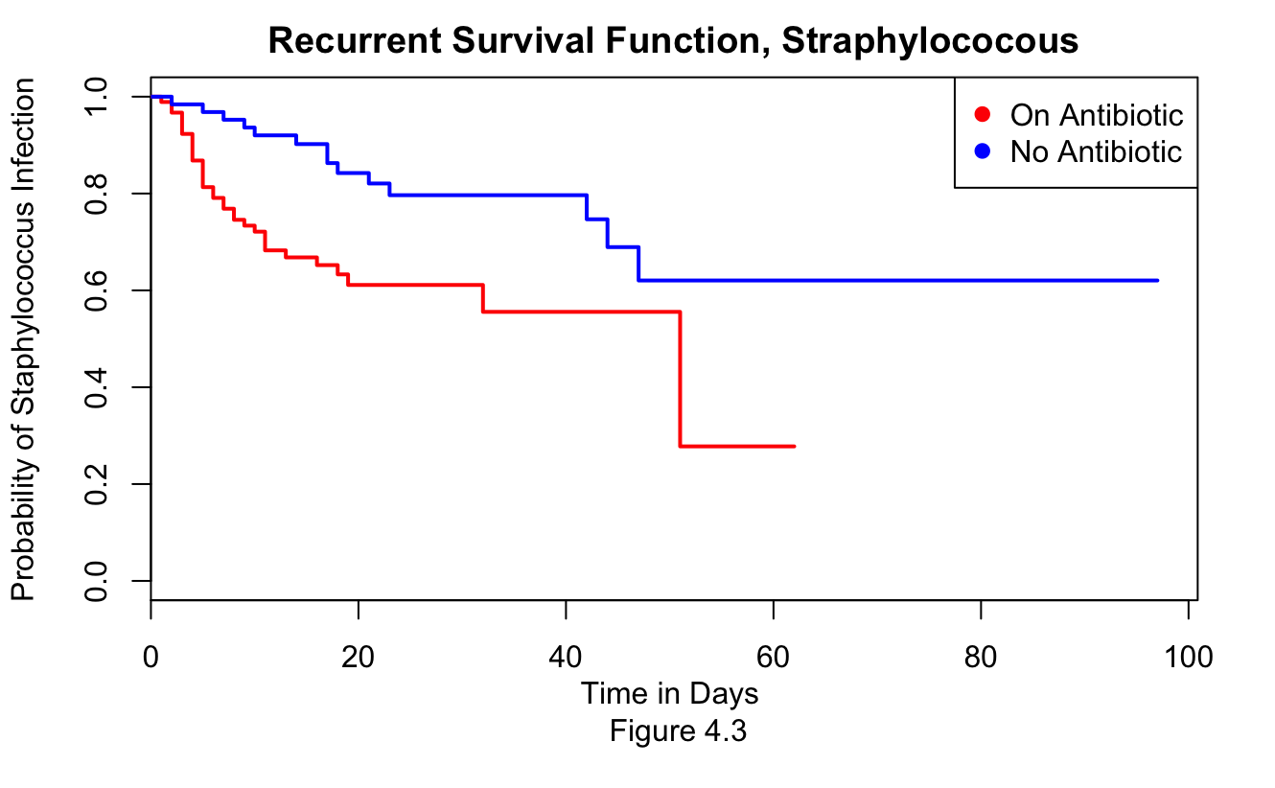

We again performed something similar in figure 4.4 as a quick overview, since some patients underwent an excision procedure, we were curious to see if this had any effect on the survival rate for infection.

From, figure 4.4, we noticed that there is a difference between those who underwent excision and those who did not. This led us to conclude that perhaps undergoing excision would be a form of a preventative measure. Since we now know that taking anti-biotics and undergoing excision lowered the risk of an infection. We then suspected that undergoing both would result in the greatest risk decrease.

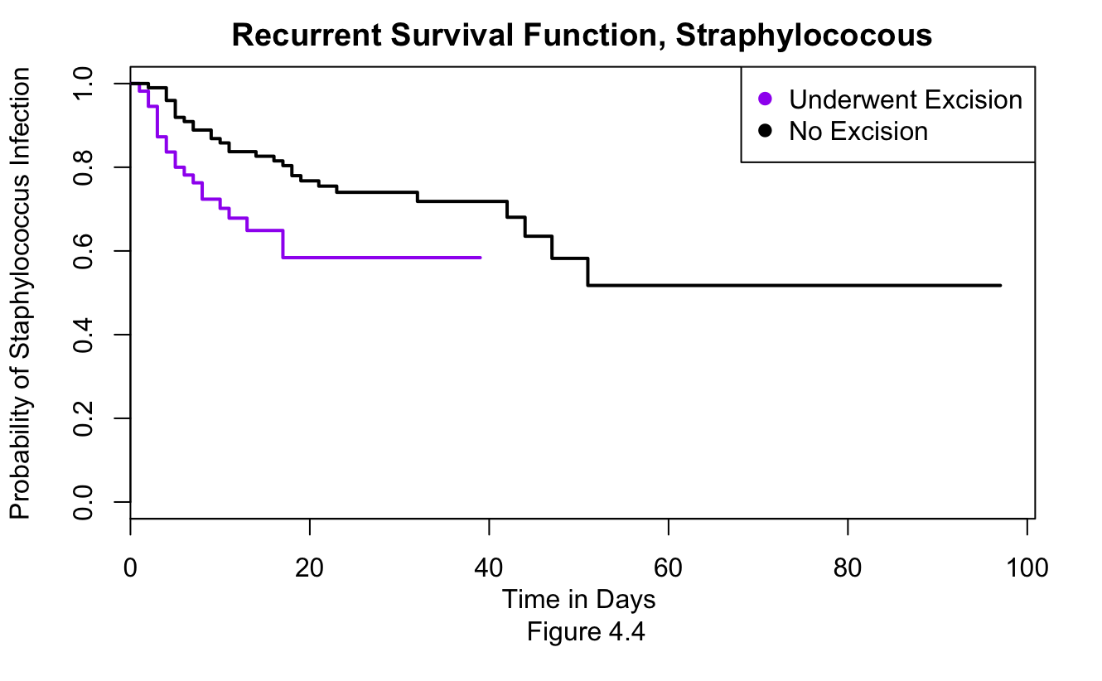

Thus with this assumption, we then tested to see if there was an effect of taking an antibiotic at the different time episodes that we mentioned previously. This resulted in the following test

Call:

coxph(formula = Surv(tstart, tstop, D3) ~ D1 + D2 + D2:(TimeGroup),

data = burn2)

n= 240, number of events= 48

coef exp(coef) se(coef) z Pr(>|z|)

D1 -0.6198 0.5380 0.3209 -1.931 0.0534 .

D2 -1.4850 0.2265 0.8286 -1.792 0.0731 .

D2:TimeGroup 0.4583 1.5814 0.6093 0.752 0.4520

---

Signif. codes: 0 ‘***’ 0.001 ‘**’ 0.01 ‘*’ 0.05 ‘.’ 0.1 ‘ ’ 1

exp(coef) exp(-coef) lower .95 upper .95

D1 0.5380 1.8586 0.28685 1.009

D2 0.2265 4.4148 0.04465 1.149

D2:TimeGroup 1.5814 0.6323 0.47903 5.221

Concordance= 0.669 (se = 0.043 )

Rsquare= 0.058 (max possible= 0.839 )

Likelihood ratio test= 14.44 on 3 df, p=0.002

Wald test = 12.97 on 3 df, p=0.005

Score (logrank) test = 14.18 on 3 df, p=0.003

We observed a p-value of .002, which meant that excision does indeed play an important effect in decreasing the probability of getting the infection, thus we were correct from our previous assumption regarding figure 4.4. Thus we confirmed our suspicion that undergoing excision is helpful as a counter measure and is further boosted with antibiotics.

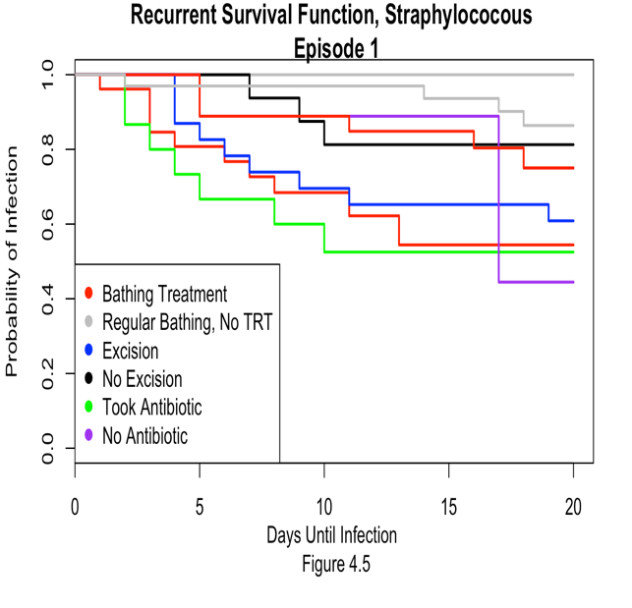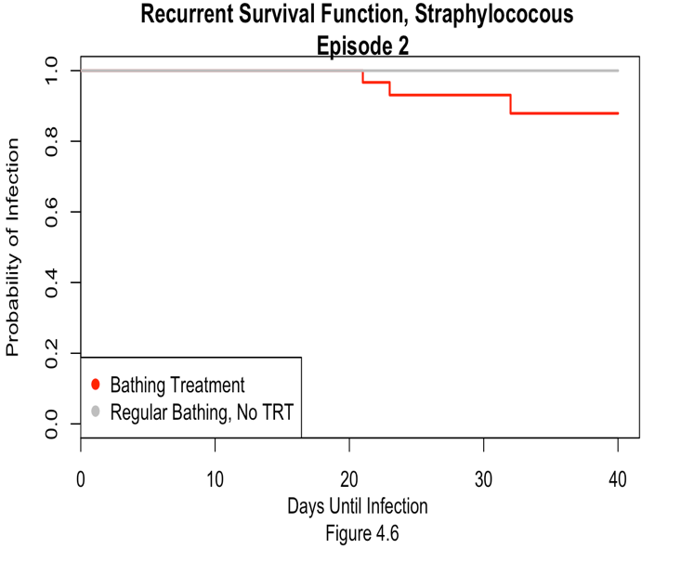

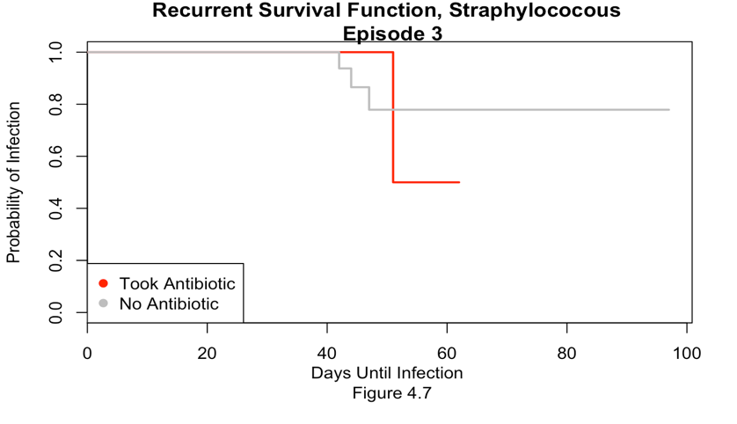

We plotted in figure 4.5 the probabilities where a subject either went and did the bath treatment, went under excision, and whether or not they took an antibiotic. We noticed during episode 1, or the first 20 days that taking an antibiotic as early as possible had the greatest effect in reducing the risk to an infection. During episode 2 we noticed that treatment group and control group were not much different, we assume this is the case because the bathing treatment on its own had no significant effect at reducing the risk after 20 days. Looking further at the antibiotic in episode 3, we see that it still continues to have the greatest effect. Thus we conclude that a recurrent event model would be the best choice as it would be able to account for the times in which a subject underwent certain procedures and if they underwent the procedure.

# Conclusion

We started by first explaining our data and trying to have a better understanding of the variables within the dataset. We found that the electric type burn had the highest risk for needing a excision procedure done. This was in line with what we had expected as the electric burns are the rarest to occur. We plotted a bar plot to understand the distribution of burn sites to have an idea of the frequency of each burn location. We noted that the trunk was the most common area to have a burn wound and we thus expected it to be an indicator for our models which it was not.

There was a difference in the survival function in regard to time to excision in groups such as gender and burn type groups under the nonparametric Kaplan-Meier estimate approach. We were not at all surprised to find significant difference in these groups. We however found a different conclusion when we had later fitted a coxph model and found that due to other variables, some differences in the groups were actually the same which we attributed was due to interaction effects. Our model for time to staphylococcus infection correctly satisfied the cox proportional hazard assumption. Negative Log log plots and residuals were used to conduct the diagnostics in the model and thus cross validated the ph assumption by three methods. We however found interesting and confusing interpretation of the coefficients in the model, we attributed it that it was perhaps balanced by the same variable being in an interaction with another variable. We then graphed the effect of bathing, excision, and antibiotics in time episodes to see if a recurrent events model would be appropriate and we thus conclude that it would account for time episodes better than our original model.

# Bibliography, Works Cited

Barret, Juan P., and David N. Herndon. “Effects of Burn Wound Excision on Bacterial Colonization and Invasion.” *Plastic and Reconstructive Surgery*, vol. 111, no. 2, 2003, pp. 744–750., doi:

Ichida, J M, et al. “Evaluation of Protocol Change in Burn-Care Management Using the Cox Proportional Hazards Model with Time-Dependent Covariates.” *Current Neurology and Neuroscience Reports.*, U.S. National Library of Medicine, Feb. 1993, [www.ncbi.nlm.nih.gov/pubmed/8456213](http://www.ncbi.nlm.nih.gov/pubmed/8456213).

Merchant, N, et al. “Management of Adult Patients with Buttock and Perineal Burns: The Ross Tilley Burn Centre Experience.” *Current Neurology and Neuroscience Reports.*, U.S. National Library of Medicine, 1 Oct. 2014, www.ncbi.nlm.nih.gov/pubmed/25250608.

# Appendix, R Code

library(survival)

library(tidyverse)

library(KMsurv)

#Exploratory Data Analysis

data("burn")

burn.dataset<- data("burn")

sum(burn$Z10) #number of patients with burn in throat

mean(burn$Z4) #avg body burn percentage is 24.69481

summary(burn) #5 point summary for all variables #z4 would be good

sum(burn$Z2)

bodilyburncount <- subset(burn, select=Z5:Z10) %>% colSums()

bodilyburncount #setting up for barplot

barplot(bodilyburncount, col = "cadetblue1", ylab = "Number of Patients",

xlab="Area of Burn Location",

main="Bar Plot of Patient Burn Location",

names.arg=c("Head", "Buttock","Trunk", "Upper Leg", "Lower Leg", "Respiratory"))

sum(burn$Z1) #total patients with body cleansing

burn

#number of females in dataset

females.in.study <- sum(burn$Z2)

#Number of white people in group

sum(burn$Z3)

# Z11 ( Type of Burn), Understanding nature of burn type through KM

Typeofburn.km <- survfit(Surv(burn$T1, burn$D1) ~ Z11, data = burn)

plot(Typeofburn.km, xlab = "Time in Days till Excision \n Figure 1.2", ylab = "Probability of Needing Excision", main = "Survival Rates Between Burn Type (Excision)", col = c("purple", "blue", "gold", "red"))

legend("right", legend=c("Chemical", "Scald", "Electricity", "Flame"), col = c("purple", "blue", "gold", "red"), pch=rep(19,2))

log.rank.test.typeofburn <- survdiff(Surv(T1, D1)~Z11, data = burn)

log.rank.test.typeofburn

plot(Typeofburn.km, mark="+",lwd=2,col = c("purple", "blue", "yellow", "red"), fun="cloglog", xlab="Days", ylab="Log-Log S", main = "log log plot on type of burn")

legend(3,1,c("chemical", "scald", "electricity", "flame"),fill=c("purple", "blue", "yellow", "red")) #considering no other covariates.

#routine bathing vs chemical bathing effect

treatmentcoxph <- coxph(Surv(T2, D2)~Z1, data=burn)

treatmentcoxph

summary(treatmentcoxph)

#now checking under excision

treatmentcoxph2 <- coxph(Surv(T1, D1)~Z1, data=burn)

treatmentcoxph2

summary(treatmentcoxph2)

#p-value of .008, reject the null hypothesis that no difference exists, thus we know that there is significant difference betweeen bathing in the treatent and routine bathing. Bathing in treatment results in a decrease of the infection risk.

#treatment group graph

treatmentgroups<- survfit(Surv(T2, D2)~Z1, data = burn)

summary(treatmentgroups)

plot(treatmentgroups, xlab="Time in Days till Excision \n Figure 3.1",

ylab="Probability of Needing Excision",

main="Treatment Survival Function Comparison",

col=c("skyblue","purple"))

legend("topright",legend=c("Control Group, Routine Bath","Treatment Group, Chemical Bath"), col=c("skyblue","purple"), pch=rep(19,2))

# end of treatment graph

# for excision

#time 1

excision.km <-survfit(Surv(burn$T1, burn$D1)~1)

plot(excision.km, xlab= "Time for Excison", ylab="Probability of Needing Excision", conf.int=TRUE,

mark.time=TRUE, col = "maroon")

#excision km gender

excision.gender <- survfit(Surv(burn$T1, burn$D1)~Z2, data=burn)

summary(excision.gender)

plot(excision.gender, xlab="Time in Days till Excision \n Figure 2.1",

ylab="Probability of Needing Excision",

main="Excision Gender Survival Function Comparison",

col=c("green","purple"), conf.int=TRUE)

legend("top",legend=c("Male","Female"), col=c("green","purple"), pch=rep(19,2))

excision.coxph <- coxph(Surv(T1,D1)~Z2,data=burn) #log rank test for male/female difference

excision.coxph

excision.coxph2 <- coxph(Surv(T1,D1)~.,data=burn)

excision.coxph2

Models <- step(excision.coxph2, direction = "backward")

Models

bestfit <- coxph(Surv(T1, D1) ~ Z1 + Z2 + Z4 + Z8 + Z9 + T3, data = burn)

summary(bestfit)

cox.zph(bestfit)

befit <- coxph(Surv(T1, D1) ~ (Z1 + Z2 + Z4 + Z8 + Z9 + T3)^2, data = burn)

step(befit, direction = "backward")

befit1 <- coxph(Surv(T3, D3) ~ (Z1 + Z2 + Z3 + Z6 + D1 + D2)^2, data = burn)

step(befit1, direction = "backward")

befit2<-coxph(Surv(T3, D3) ~ Z1 + Z2 + Z3 + Z6 + D1 + D2 +

Z1:D1 + Z2:Z3 + Z2:D1 + Z2:D2 + Z3:D2, data = burn)

befit2$coefficients

summary(befit2)

cox.zph(befit2, global = FALSE)

cox.zph(befit1, global = FALSE)

plot(survfit(bestfit, newdata=data.frame(Z2=factor(c("0","1")))), fun="cloglog",col=c("blue", "green"),xlab="Time",ylab="log(-log(S(t)))",lwd=1)

legend("topleft",legend=c("Routine Bathing","Chlorhexidine Gluconate Bath"),

pch = rep(15,2),col=c("blue","green"))

anova(excision.coxph2)

step(excision.coxph2, direction = "backward")

#time 2

Prophylacti.km <- survfit(Surv(burn$T2, burn$D2)~1)

plot(Prophylacti.km, xlab="Time to Prophlactic Treatment", ylab="Probablilty of Survival", col="green")

Prophylacti.km.gender <- survfit(Surv(T2,D2)~Z2, data=burn)

plot(Prophylacti.km.gender, xlab="Time Till Prophylacti Treatement", ylab ="Probablility of Prophylacti Treatment",

main="Prophylacti Gender Comparison", col=c("red","pink"))

legend("middle", legend=c("Male, Female"), col=c("red","pink"), phc=rep(19,2)) #dont work lol, tired. fix later

Prophylacti.coxph<- coxph(Surv(T2,D2)~Z11, data=burn)

Prophylacti.coxph

Prophylacti.coxph2<- coxph(Surv(T2,D2)~., data=burn)

anova(Prophylacti.coxph2)

step(Prophylacti.coxph2, direction = "backward")

Prophylacti.coxph

plot(Prophylacti.coxph)

#time 3

straphylocous.km <- survfit(Surv(burn$T3, burn$D3)~1)

plot(straphylocous.km, xlab="Time to Straphylocous", ylab ="Probability of Getting Sttraphylocous Infection", col="blue")

straphylocous.km.gender <- survfit(Surv(T3, D3)~Z2, data=burn)

plot(straphylocous.km.gender, xlab="Time in Days till Staphylocous",

ylab="Probability of Straphylocous",

main="Straphylocous Gender Survival Function Comparison",

col=c("green","purple"))

legend("top",legend=c("Male","Female"), col=c("green","purple"), pch=rep(19,2))

straphylocous.coxph<- coxph(Surv(T3, D3)~.^2, data=burn)

anova(straphylocous.coxph)

step(straphylocous.coxph, direction ="backward")

#gender question analysis

?burn

excision.km.ethnicity<- survfit(Surv(T1, D1)~Z3, data=burn)

summary(excision.km.ethnicity)

plot(excision.km.ethnicity, xlab="Time in Days till Excision", ylab="Probability of Excicision",

main="Ethnicity on Excision", col=c("blue", "red"))

legend("top",legend=c("White", "Non-White"),col = c("blue","red"),pch = rep(19,2))

log.rank.test.ethnicity <- survdiff(Surv(T1, D1)~Z3, data=burn)

log.rank.test.ethnicity

#extremely high p-value=1, probs something wrong.

#otherwise fail to reject null, conclude survival rate the same for ethnicities.

#question regarding survival rates for different burn

#null is no difference.

log.rank.test.burntype <- survdiff(Surv(T1, D1)~Z11, data=burn)

log.rank.test.burntype

#p-value at .04, means no difference in type of burn assuming i did this right

#diagnostics on model

rsds <- residuals(straphylocous.coxph,type = "schoenfeld")

hist(rsds,col = 5, xlab = "Residuals", main = "Residual", breaks = 20)

Z1cox <- coxph(Surv(T3,D3)~ Z1, data = burn)

Z2cox <- coxph(Surv(T3,D3)~ Z2 , data = burn)

Z3cox <- coxph(Surv(T3,D3)~ Z3 , data = burn)

Z6cox <- coxph(Surv(T3,D3)~ Z6 , data = burn)

D1cox <- coxph(Surv(T3,D3)~ D1 , data = burn)

D2cox <- coxph(Surv(T3,D3)~ D2 , data = burn)

#log log Z1

plot(survfit(Z1cox,newdata=data.frame(Z1=factor(c("0", "1")))),

fun = "cloglog", main ="Log Log Graph of Bathing Treatment" ,

xlab="Time until death(in days)", ylab = "Log(-Log(S))", lwd = 2, col = c(1:2))

legend("bottomright", legend = c("Routine Bath", "Body Cleansing"), fill = c(1:2))

#log log Z2

plot(survfit(Z2cox,newdata=data.frame(Z2=factor(c("0", "1")))),

fun = "cloglog", main ="Log Log Graph of Gender" ,

xlab="Time until death(in days)", ylab = "Log(-Log(S))", lwd = 2, col = c(1:2))

legend("bottomright", legend = c("Male", "Female"), fill = c(1:2))

#log log Z3

plot(survfit(Z3cox,newdata=data.frame(Z3=factor(c("0", "1")))),

fun = "cloglog", main ="Log Log Graph of Race" ,

xlab="Time until death(in days)", ylab = "Log(-Log(S))", lwd = 2, col = c(1:2))

legend("bottomright", legend = c("Non-White", "White"), fill = c(1:2))

#log log z6

plot(survfit(Z6cox,newdata=data.frame(Z6=factor(c("1", "0")))),

fun = "cloglog", main ="Graph of Burn Site Indicator: Buttock" ,

xlab="Time until death(in days)", ylab = "Log(-Log(S))", lwd = 2, col = c(1:2))

legend("bottomright", legend = c("Yes", "No"), fill = c(1:2))

#log log D1

plot(survfit(D1cox,newdata=data.frame(D1=factor(c("1", "0")))),

fun = "cloglog", main ="Log Log Graph of Excision Indicator" ,

xlab="Time until death(in days)", ylab = "Log(-Log(S))", lwd = 2, col = c(1:2))

legend("bottomright", legend = c("Yes", "No"), fill = c(1:2))

#log log D2

plot(survfit(D2cox,newdata=data.frame(D2=factor(c("1", "0")))),

fun = "cloglog", main ="Log Log Graph of Prophylactic Antibiotic" ,

xlab="Time until death(in days)", ylab = "Log(-Log(S))", lwd = 2, col = c(1:2))

legend("bottomright", legend = c("Yes", "No"), fill = c(1:2))

#shoenfeld residuals

befit2.res<- residuals(befit2, type = "martingale")

hist(befit2.res, col = 5, xlab = "Residuals", main = "Residual", breaks = 20)

#### Recurrent Model

### Subset D1 = 0

plot(survfit(Surv( burn$T3, burn$D3) ~ 1,

data = burn, subset = (burn$D1 == "0")), lwd = 2, xlab = "Days",

ylab = "Survival Probability", col = "blue", main = " No Extension to Infection")

plot(survfit(Surv( burn$T3, burn$D3) ~ strata(burn$Z1),

data = burn, subset = (burn$D1 == "0")), lwd = 2, xlab = "Days",

ylab = "Survival Probability", col = 2:4, main = " No Extension to Infection")

legend("topright", legend = c("No Bathing", "Bathing"), fill= c(2:4) )

#### Subset D1 =0 & D2 = 0

plot(survfit(Surv(T2,T3,D3)~1,data=burn),lwd=2,xlab="Days",ylab="S(t)")

```

```{r}

#extension code

### Due to our burn data set have mutiple events that can occur before an infection happen. We decided to use a recurrent model to test if

# events happening prior to our D3 have any effect on the survival rate of getting an infection.

burn2 = survSplit(Surv(T3, D3)~.,data=burn, cut =c(20,40), episode = "TimeGroup",

id ="sub.id",end = "tstop")

burn2

#spltting time into episodes, and creating start and stop

plot(survfit(Surv(tstart,tstop,D3)~1,data=burn2),lwd=2,xlab="Time in Days \n Figure 4.1",ylab="S(t)",col="maroon",main="Recurrent Survival Function, Straphylococous")

plot(survfit(Surv(tstart,tstop,D3)~Z1,data=burn2),lwd=2,xlab="Time in Days \n Figure 4.2",ylab="Probability of Staphylococcus Infection",col=c("red","gray"), main="Recurrent Survival Function, Straphylococcous")

legend("topright", legend = c("Bathing Treatment","Regular Bathing, No TRT"), col = c("red","gray"),pch=rep(19,2))

plot(survfit(Surv(tstart,tstop,D3)~D2,data=burn2),lwd=2,xlab="Time in Days \n Figure 4.3",ylab="Probability of Staphylococcus Infection",col=c("red","blue"), main="Recurrent Survival Function, Straphylococous")

legend("topright", legend = c("On Antibiotic","No Antibiotic"), col = c("red","blue"),pch=rep(19,2))

plot(survfit(Surv(tstart,tstop,D3)~D1,data=burn2),lwd=2,xlab="Time in Days \n Figure 4.4",ylab="Probability of Staphylococcus Infection",col=c("purple","black"), main="Recurrent Survival Function, Straphylococous")

legend("topright", legend = c("Underwent Excision","No Excision"), col = c("purple","black"),pch=rep(19,2))

rets.ft <- coxph(Surv(tstart, tstop, D3) ~ D1 + D2 + D2:(TimeGroup),

data=burn2)

summary(rets.ft)

anova(rets.ft)

beta2 <- coef(rets.ft)[3]

se.beta2 <- sqrt(vcov(rets.ft)[3,3])

exp( beta2 +c(-1.96, 1.96)*se.beta2 )

plot(survfit(Surv(tstart,tstop,D3)~Z1+D1+D2,

data=burn2,

subset=(burn2$TimeGroup == "1")),

lwd=2, col=c("red","gray","blue","black","green","purple"),xlab="Days Until Infection \n Figure 4.5",ylab="Probability of Infection",main="Recurrent Survival Function, Straphylococous \n Episode 1")

legend("bottomleft", legend = c("Bathing Treatment","Regular Bathing, No TRT","Excision","No Excision", "Took Antibiotic","No Antibiotic"), col = c("red","gray","blue","black","green","purple"),pch=rep(19,2))

plot(survfit(Surv(tstart,tstop,D3)~Z1,

data=burn2,

subset=(burn2$TimeGroup == "2")),

lwd=2, col=c("red","gray"),xlab="Days Until Infection \n Figure 4.6",ylab="Probability of Infection",main="Recurrent Survival Function, Straphylococous \n Episode 2")

legend("bottomleft", legend = c("Bathing Treatment","Regular Bathing, No TRT"), col = c("red","gray","blue","black","green","purple"),pch=rep(19,2))

plot(survfit(Surv(tstart,tstop,D3)~D2,

data=burn2,

subset=(burn2$TimeGroup == "3")),

lwd=2, col=c("red","gray"),xlab="Days Until Infection \n Figure 4.7",ylab="Probability of Infection", main="Recurrent Survival Function, Straphylococous \n Episode 3")

legend("bottomleft", legend = c("Took Antibiotic","No Antibiotic"), col = c("red","gray"),pch=rep(19,2))

```